**Datahaven for Nav Job Aid - Reports**



1. Double Click icon on desktop to launch **Navision**.

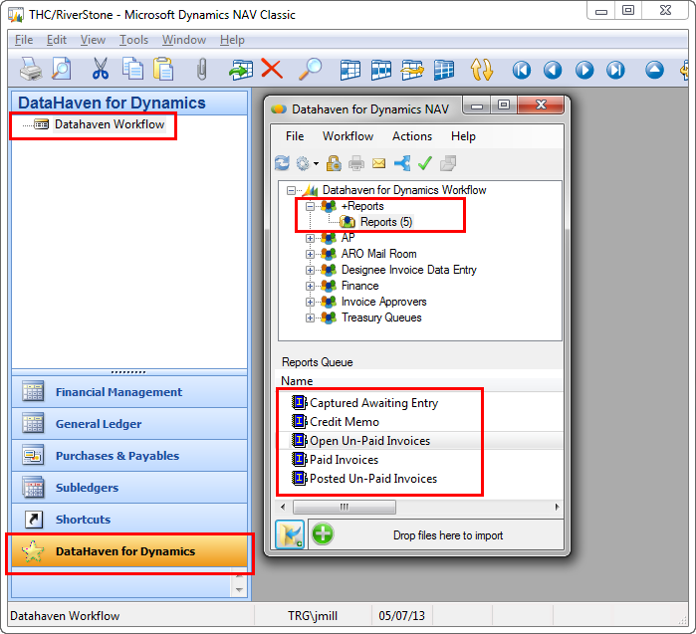***Microsoft Dynamics NAV*** *opens*

**4**

**3**

1. Click 

**5**

**2**

1. Click **Datahaven Workflow**.

**Datahaven for Dynamics NAV** opens.

1. Double Click **+Reports.**

**Reports** folder opens.

1. Double Click on the **Report Name** that you would like to run.

The report will open in an Internet Explorer browser.



1. To **Export** any **Report** into a CSV (comma delimited) or another format, click on the button and select format. A separate Internet Explorer Browser opens with a **File Download** pop-up.

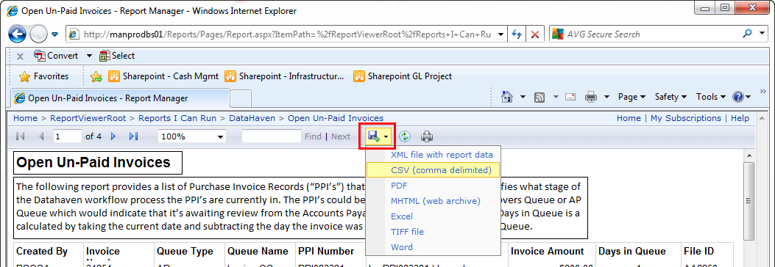

**6**

1. In the **File Download**, select **Open**. The report opens in the format you selected.

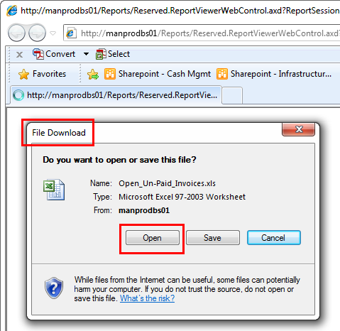

**7**

Detailed below is a description of the information that each of the reports will provide. The reports are listed and described below in chronological order of the Datahaven workflow.

**Captured Awaiting Entry -** This report provides a list of documents (Invoices or Supporting Data) that have been captured in a Designee’s queue in the Datahaven workflow process.  These documents have not yet been linked to a Purchase Invoice Record “PPI” or the PPI has not yet been created.  ***Note:***  The column Days in Queue is calculated by taking the current date and subtracting the day the invoice was first captured in a Designee’s Queue.

**Open Un-Paid Invoices –** This report provides a list of Purchase Invoice Records (“PPI’s”) that have been created and identifies what stage of the Datahaven workflow process the PPI’s are currently in. The PPI’s could be in a Designee’s Queue, Approvers Queue or AP Queue which would indicate that it’s awaiting review from the Accounts Payable Team.  ***Note:*** The column **Days in Queue** is a calculated by taking the current date and subtracting the day the invoice was first captured in a Designee’s Queue.

**Posted Un-Paid Invoices -** This report identifies invoices where all the appropriate Approvals and Accounts Payable reviews have taken place; however, a check has not been issued as the invoice(s) are not due at this time.   ***Note:***  The column **Date Entered Workflow** reflects the day the invoice was first captured in a Designee’s Queue.

**Paid Invoices** This report provides a list of invoices have been paid through the *Datahaven Process* by the Accounts Payable Team.  The corresponding Check No. and Check Date are listed on this report should a vendor have a question regarding if an invoice has been paid.  *Note:*  The column Inv Processing Time is calculated by taking the Check Date and subtracting the Date Entered Workflow.  The column Date Entered Workflow reflects the day the invoice was first captured in a Designee’s Queue.

1. Before running this report, select a **Start Date** and **End** **Date.** This date range is driven off when the document first entered the Datahaven Workflow.



**9**

**8**

1. Click on **View Report. Report** opens

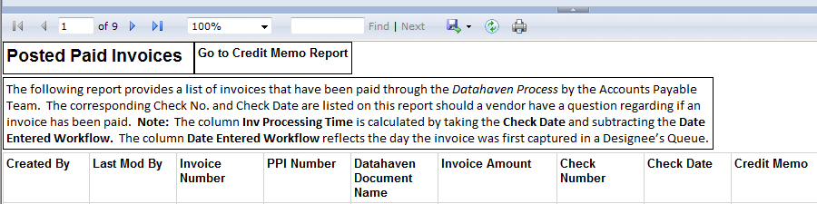

**100**

**110**

1. If a **Credit Memo** has been processed by the Accounts Payable Team, a ‘Yes’ will appear in the **Credit Memo** column field. A **Credit Memo** represents a PPI that was ultimately not paid by Accounts Payable for a specific reason. Please contact the Accounts Payable Team directly to obtain further details on the Credit Memo.
2. If a **Credit Memo** was processed, click the button at the top of **Posted Paid Invoices** report.The **Credit Memo** report open.

|  |  |
| --- | --- |
|  |  |